PRESS RELEASE November 28th 2023
Orkla Danmark and FERM FOOD create the future of plant-based foods: Fermented ingredients to boost sales of plant-based foods 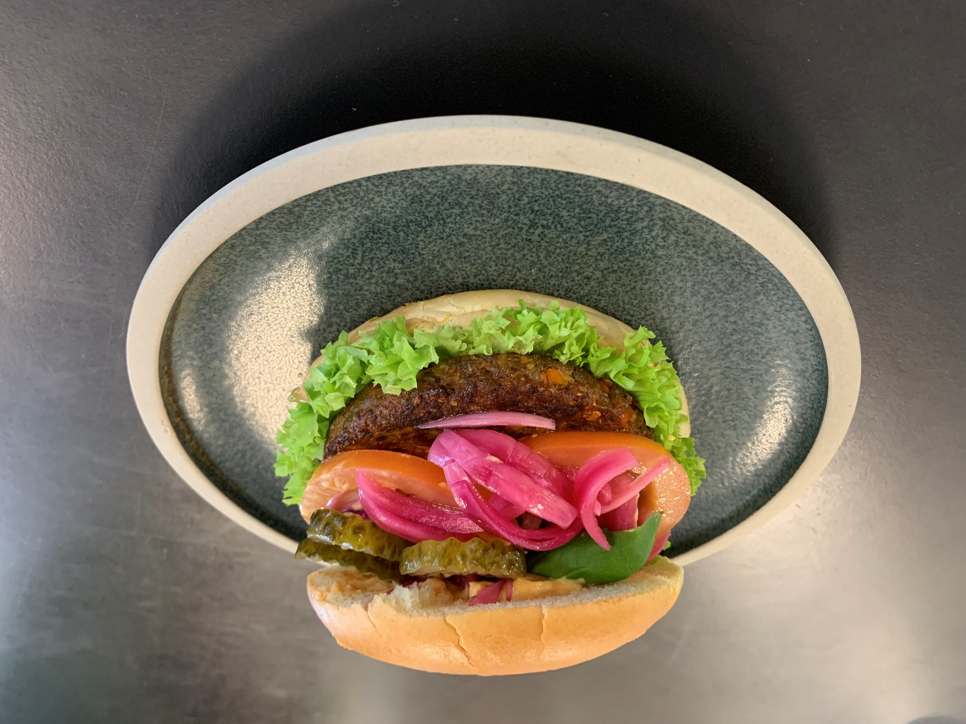
Image: FERM FOOD and Orkla Danmark have developed a plant-based patty made from fermented rye, Orkla Danmark.
A close collaboration between the food giant Orkla Danmark and the Danish ingredient company FERM FOOD has been successful, and the partners are now launching the first in a series of products designed to entice more consumers to choose plant-based foods.
When development manager Søren Lange from FERM FOOD and product developer Torbjørn Tyndkjær-Thomsen from Orkla Danmark joined forces in the spring of 2023, the goal was clear: to develop tasty and healthy plant products to be used in the 20 most common dishes in European households.
After intensive development and testing, the first food is ready for large-scale production. "We have developed a new type of plant-based food with fermented rye, which has received extremely positive feedback in consumer tests. Lactic acid-fermented ingredients have the potential to revolutionise the way we compose foods because we can use more local ingredients that taste better and, due to the fermentation process, become multifunctional, shortening the ingredient list and preserving the natural health of the raw materials," says Torbjørn Tyndkjær-Thomsen from Orkla Danmark about the possibilities.
At the Jutlandic factory in Skovlund, the new plant product with fermented rye has just passed the large-scale test, and it can already be experienced at the B2B food fair, Food Ingredients Europe, from November 28th to 30th at FERM FOOD's booth number 3.0J151.

Plant products made from fermented rye
FERM FOOD's fermented rye makes up a significant part of the product. The rye contributes to nutritional value and texture while binding the ingredients together. The binding ability works both when frozen, after thawing, during heating, and without the addition of fat:
"It does not burn and maintains its shape during boiling and frying as well as when frozen," says Head of Development Søren Lange from FERM FOOD, who, together with Orkla Danmark, predicts a great future for the new type of plant-based foods with fermented ingredients. "At Orkla Danmark, we are developing the next generation of plant-based foods with fermented ingredients. We want to make plants the heroes in our foods. Therefore, in generation 2.0, you can recognise the ingredients which have gone through minimal processing," says the Orkla developer.

Nominated for Innovation of the Year Award
Orkla Danmark is not alone in recognising the benefits of fermented plant ingredients. In addition to significant interest from global food companies, FERM FOOD, the only Danish company in the group, is nominated for the Plante-based Innovation Award of the Year at the Food Ingredients Europe trade show. "I have never experienced such great interest from the food industry as with our fermented binders. The market has a big gap for naturally fermented ingredients in plant products and hybrids. We are keeping our fingers crossed to win, so even more professionals in the industry learn about the possibilities with fermented grains," says Søren Lange from FERM FOOD.
Properties of fermented grains
Fermented grains have a wide range of properties that almost all food categories can benefit from. The products can be used as ingredients in baking, meat products, and the plant-based category, contributing, among other things, to:

- Unique binding ability
- Malleability
- Coherence
- Fullness and texture
- High water-binding capacity
- "Gumminess"
- Heat and frost stability
- Naturally preserved and clean label
- Low activation temperature
- Improved nutrient profile in the finished product (including prebiotics and increased availability of nutrients)
- Low CO2 footprint

www.ferm-food.com

For more information, contact:
Søren Lange, Development Director, FERM FOOD, soren@ferm-food.com, phone: +45 20 72 52 64
Kim Ege Møller, Communications Manager, Orkla Denmark, kim.ege.moeller@orkla.dk, phone: +45 29 38 76 55

